Sales and Scheduling Test

Name: Neron Nelson Parmar

Student ID: 171690217

Email ID: nparmar22@myseneca.ca

Course: SYD366

Prof: Hesam Akbari

Test: Sales and Scheduling Test

Date: 4/19/23

**Question 1:**

**Class Diagram for Sales:**

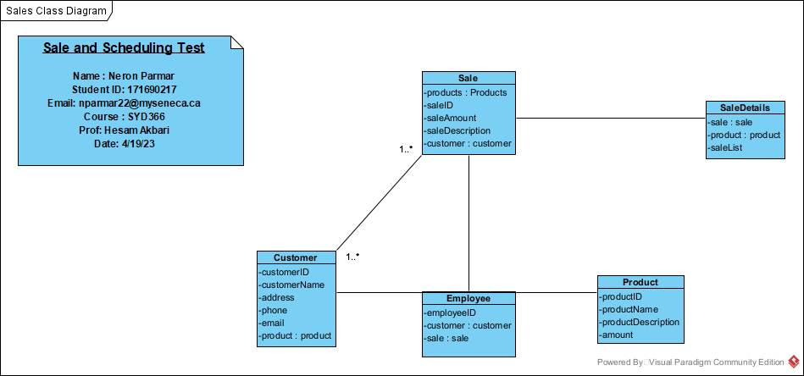

**Question 2:**

**Sequence Diagram for Sales:**

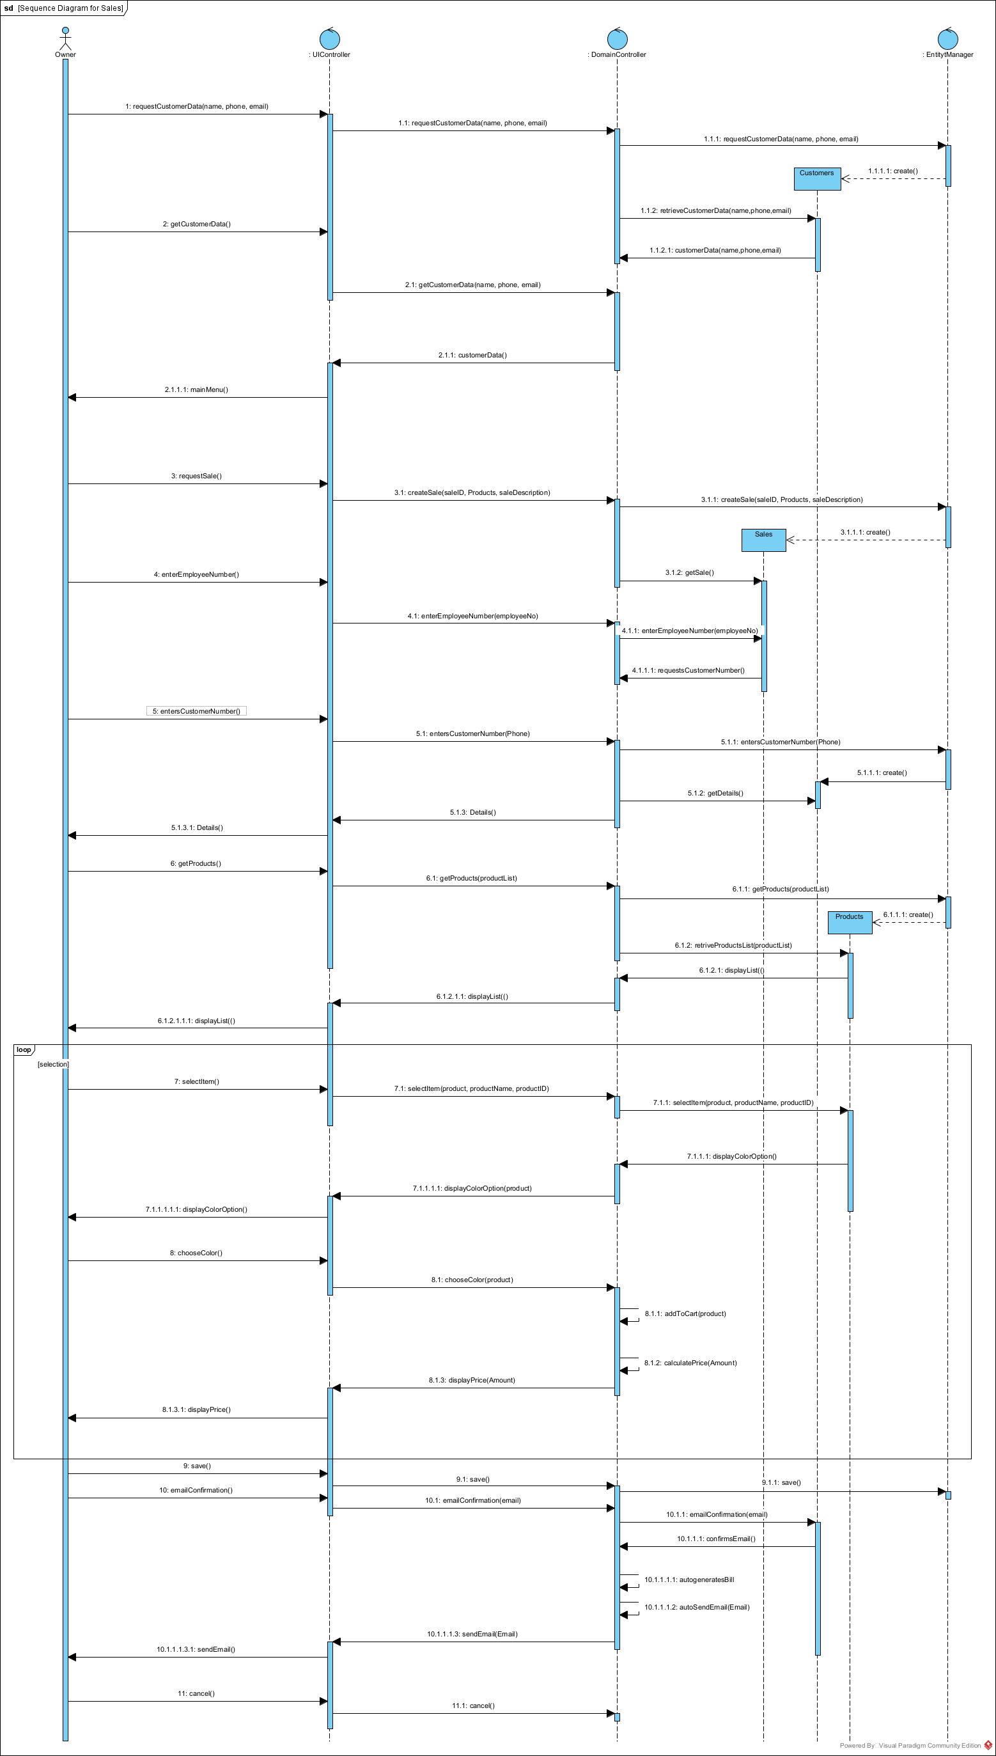

**Question 3:**

In the scenario when the customer purchases more than one product, my model will need not need any kind of change as I have got loop in it so a customer can purchase any item more than one count of it as the list of product will be displayed to them for selection and whenever the employee will select save option it will proceed further to the email confirmation stage to send the bill by the email. However, if I wouldn’t have included the save option then there might be situation to change the model as it would allow only one item to be selected. Yet, according to the above picture of the sequence diagram as my model has the save option, therefore, it does not need any change and can have multiple item selections by the customer.

**Question 4:**

If the fitness center is trying to offer a sale of ‘Buy one, get one at half price’, then unfortunately my model is not that capable enough to get the amount calculated as it would mess up having double amount prices displayed on bill. Thus, first of all I will need to add one more function named as discountOnSale() and will have to add the calculation according to the sale demand or sale prices, such as if x item is selected and is same as selected then original price + (original price / 2). Therefore, as a result I will have to change the program according to the sale requirement of prices.

**Part 2: Scheduling**

**Question 5:**

**Class Diagram for Schedule:**

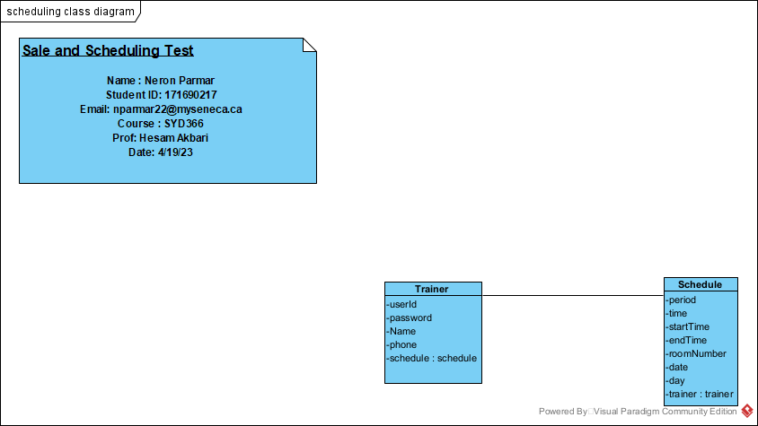

**Question 6:**

**Sequence Diagram for Schedule:**

